

**Daffodil International University**

**School Management System**

Project Document

***SWE-313***

***Dot Net Programming***

***Submitted By***

Raihan Mahmud (161-35-1542)

B.Sc. in SWE

Section: B

***Submitted To***

**Asif Khan Shakir**

Lecturer

Department of Software Engineering

Daffodil International University

**INDEX**

|  |  |  |
| --- | --- | --- |
| **Sr. No** | **Title** | **Page No** |
| 1 | Abstract | 1 |
| 2 | Functional Specification | 2 |
| 3 | Use Case Diagram | 2-3 |
| 4 | Data Dictionary | 3-5 |
| 5 | ER Diagram | 5 |
| 6 | System Screen Shots | 6 |
| 6.1 | Home page | 6 |
| 6.2 | View students | 6 |
| 6.3 | View teachers | 7 |
| 6.4 | Notice board | 7 |
| 6.5 | About | 7 |
| 6.6 | Contact | 7 |
| 6.7 | Register | 8 |
| 6.8 | Login | 8 |
| 6.9 | Forgot password | 9 |
| 610 | Admin page | 9 |
| 6.11 | Add students | 10 |
| 6.12 | Search students for update/delete | 10 |
| 6.13 | Add teachers | 11 |
| 6.14 | View teachers update/delete | 11 |
| 6.15 | Publish notice/delete | 12 |

* **Abstract (Project Profile)**

|  |  |
| --- | --- |
| **Project Title** | **Smart School** |
| **Objective** | This system provide facilities to store students/teachers info, notice board. Teachers, parents, school community and education bureau officials to view students/teachers info, notice board and know about school. |
| **Platform** | Web Based Application |
| **Front End** | [Asp.Net With C#]  Framework Version 4.5 |
| **Database** | SQL Server 2014 |
| **Project Duration** | 2weeks |

* **Functional Specification**
* **User Module**
* User can view students info
* User can view teachers info
* User can view notice board
* **Admin Module**
* Admin can login this site
* Admin can add students/teachers info
* Admin can update/delete students/teachers info
* Admin can publish notice
* Admin can delete notice
* **Use Case Diagram**
* **Use Case Diagram(Admin)**

***Figure-1.1: Use case diagram.***

* **Use Case Diagram(User)**

***Figure-1.2: Use case diagram.***

* **Data Dictionary**

Table name: **Login**

Description: To keep details of login

Primary key: ID

|  |  |  |  |  |
| --- | --- | --- | --- | --- |
| Sr. No. | Field Name | Data Type/Size | Constraint | Description |
| 1 | ID | int | Primary Key | Auto generate login id |
| 2 | Email | nvarchar(50) | Not null | Store email |
| 3 | User_name | nvarchar(50) | Not null | Store user name |
| 4 | Password | nvarchar(50) | Not null | Store password |

Table name: **Notices**

Description: To keep detail of notices

Primary key: Id

|  |  |  |  |  |
| --- | --- | --- | --- | --- |
| Sr. No. | Field Name | Data Type/Size | Constraint | Description |
| 1 | Id | int | Primary Key | Auto generate  notice id |
| 2 | Title | nvarchar(50) | Not null | Store notice title |
| 3 | Description | nvarchar(500) | Not null | Store notice description |
| 4 | Date_of_Publish | date | Not null | Store publish date |

Table name: **Students**

Description: To keep details of students

Primary key: ID

|  |  |  |  |  |
| --- | --- | --- | --- | --- |
| Sr. No. | Field Name | Data Type/Size | Constraint | Description |
| 1 | ID | int | Primary Key | Auto generate students id |
| 2 | Name | nvarchar(50) | Not null | Store students name |
| 3 | Fathers_name | nvarchar(50) | Not null | Store students fathers name |
| 4 | Mothers_name | nvarchar(50) | Not null | Store students mothers name |
| 5 | Date_of_Birth | date | Not null | Store students birthday date |
| 6 | Date_of_Admission | date | Not null | Store students admission date |
| 7 | Gender | nvarchar(50) | Not null | Store students gender |
| 8 | Class | int | Not null | Store students class |
| 9 | Class_Roll | int | Not null | Store students class roll no |
| 10 | Phone | char(11) | Not null | Store students phone numbers |
| 11 | Email | nvarchar(50) | Not null | Store students email |
| 12 | Address | nvarchar(200) | Not null | Store students address |

Table name: **Teachers**

Description: To keep details of teachers

Primary key: ID

|  |  |  |  |  |
| --- | --- | --- | --- | --- |
| Sr. No. | Field Name | Data Type/Size | Constraint | Description |
| 1 | ID | int | Primary Key | Store teachers id |
| 2 | Name | nvarchar(50) | Not null | Store teachers name |
| 3 | Designation | nvarchar(50) | Not null | Store teachers designation |
| 4 | Gender | nvarchar(50) | Not null | Store teachers gender |
| 5 | Date_of_Join | date | Not null | Store teachers join date |
| 6 | Phone | char(11) | Not null | Store teachers phone number |
| 7 | Email | nvarchar(50) | Not null | Store teachers email |
| 8 | Address | nvarchar(200) | Not null | Store teachers address |

* 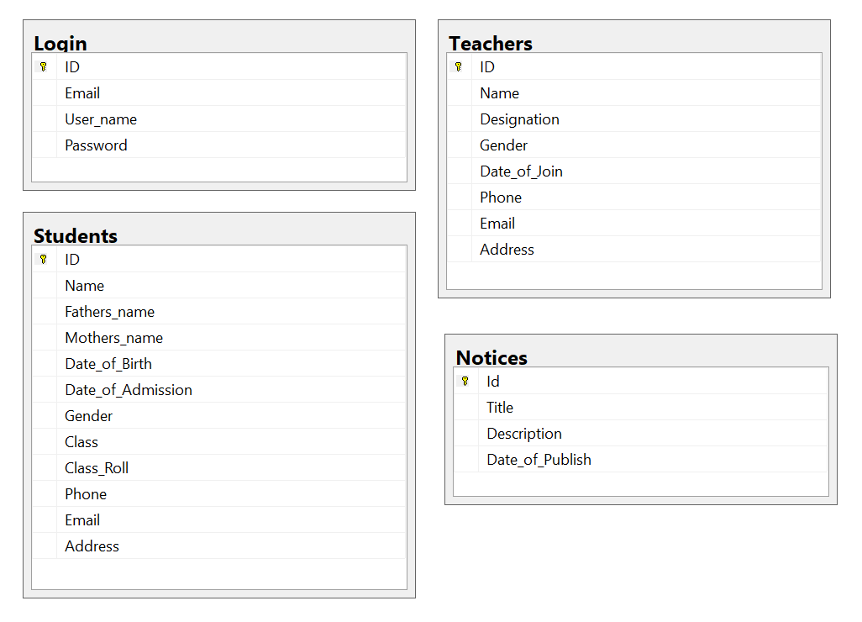**ER Diagram**

***Figure-2: Relationship Diagram of the Tables.***

* **System Screen Shots**
* 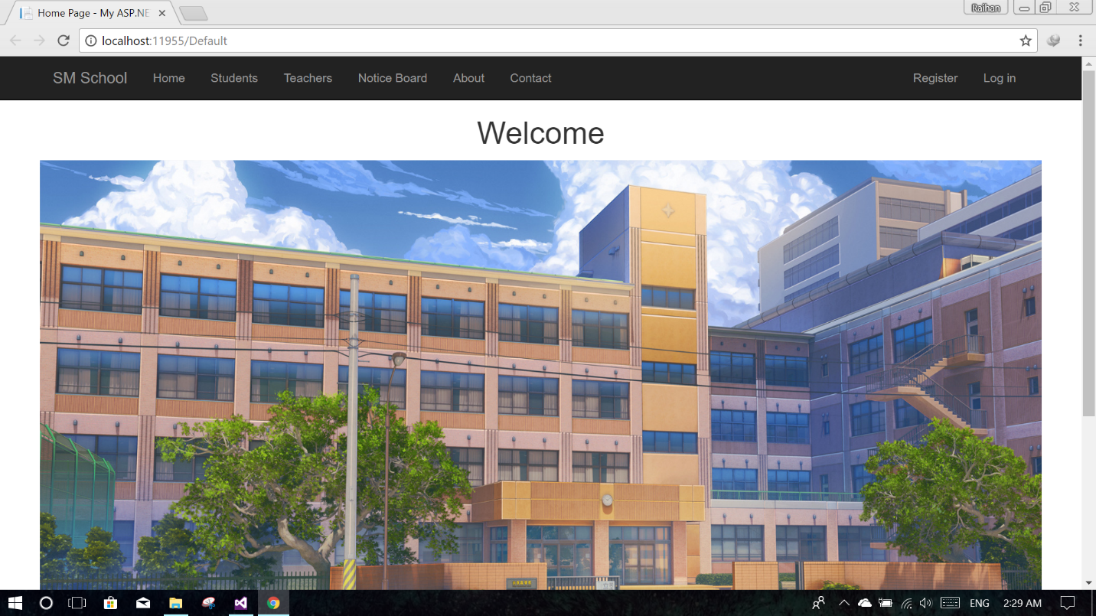**Home page:**

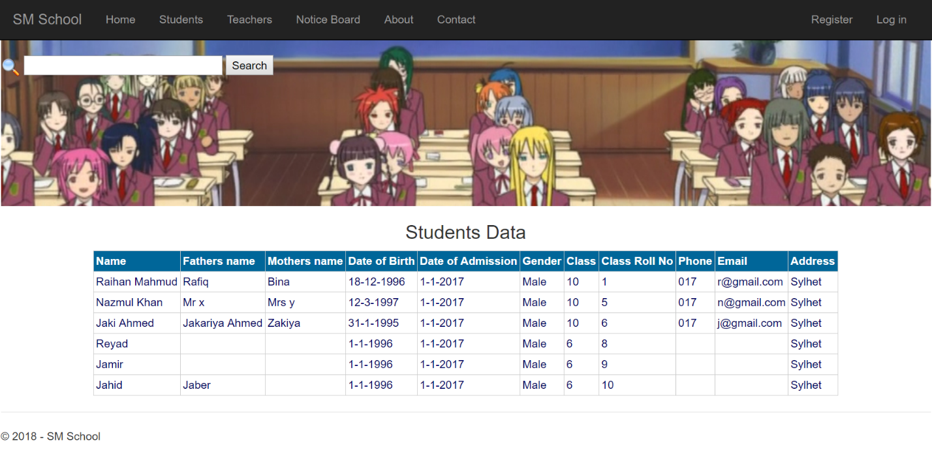

* **View students:**
* 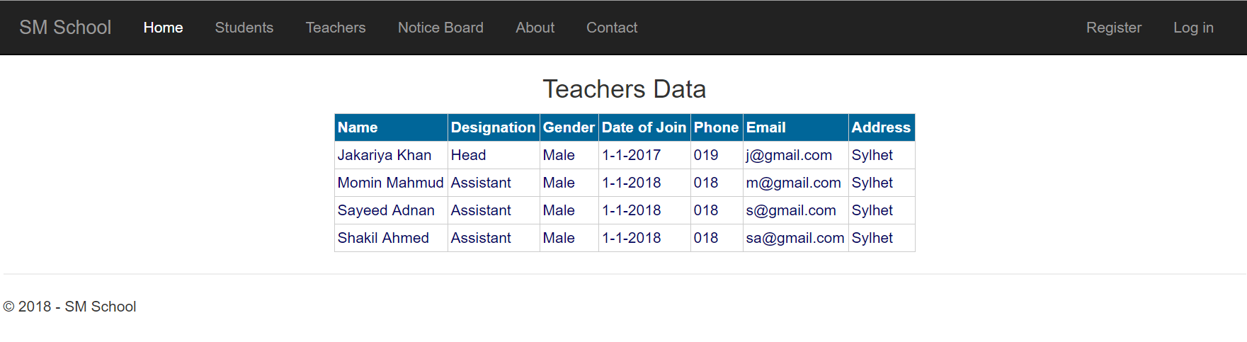**View teachers:**

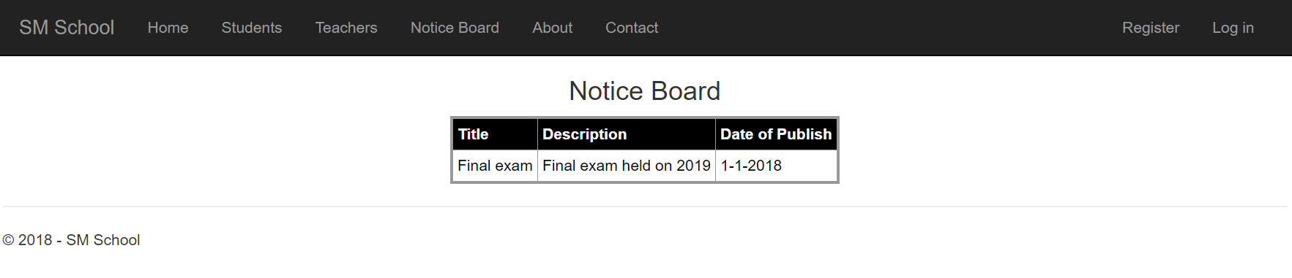

* **Notice board:**
* 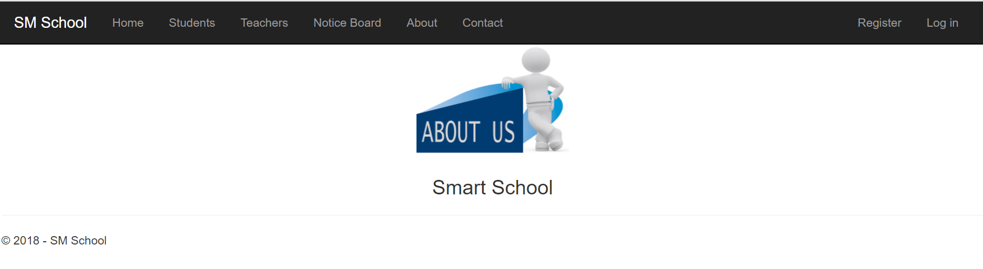**About:**
* 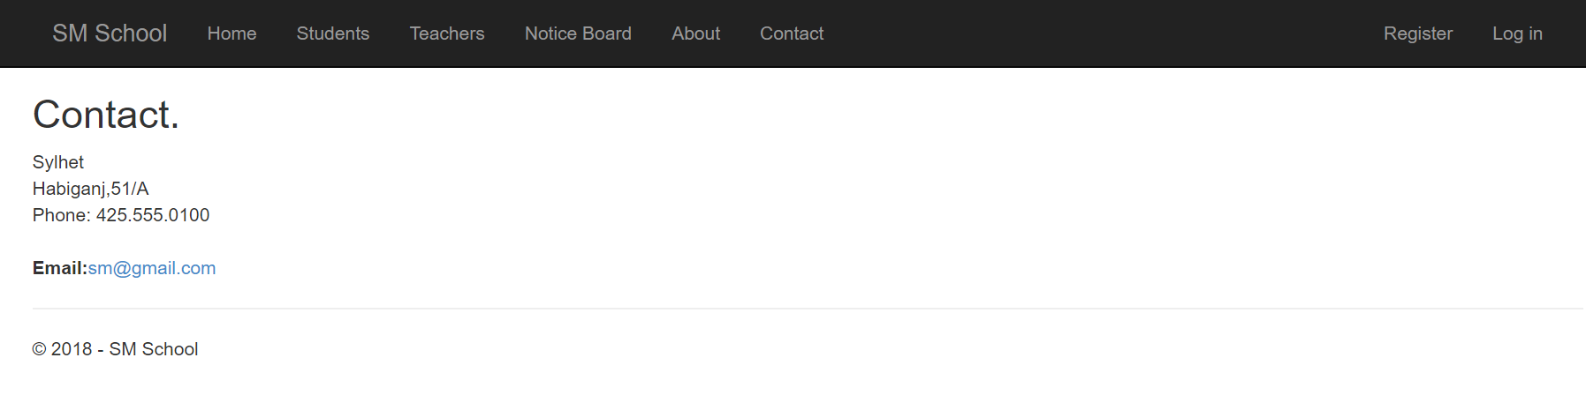**Contact:**
* 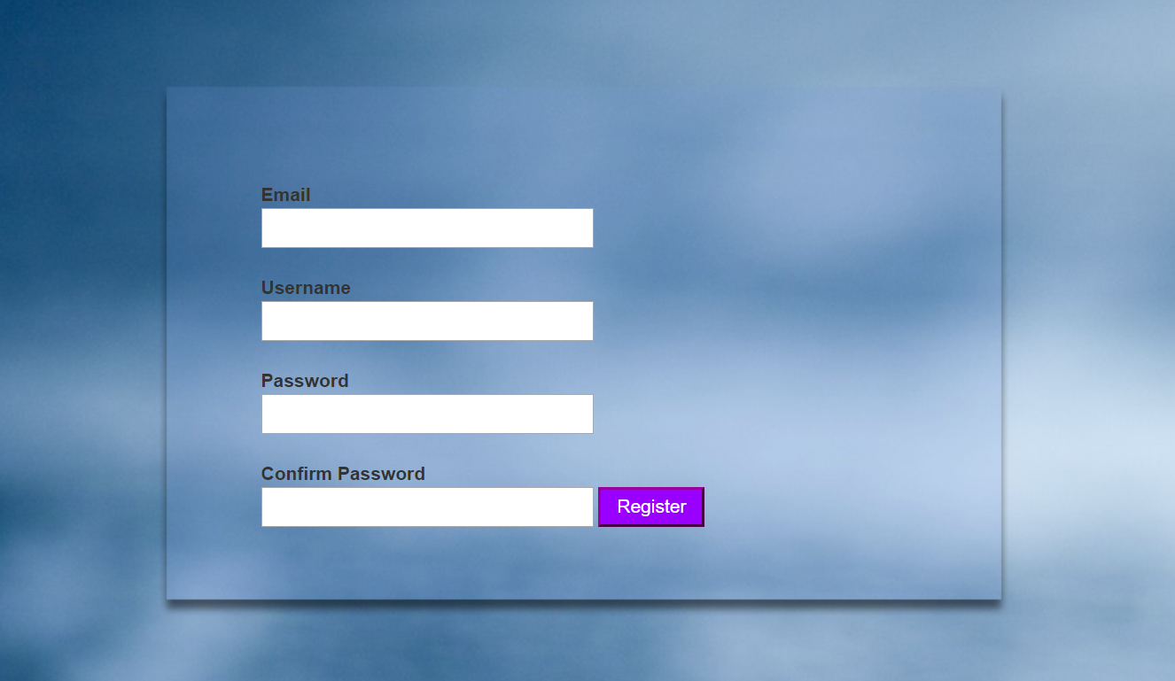**Register:**
* 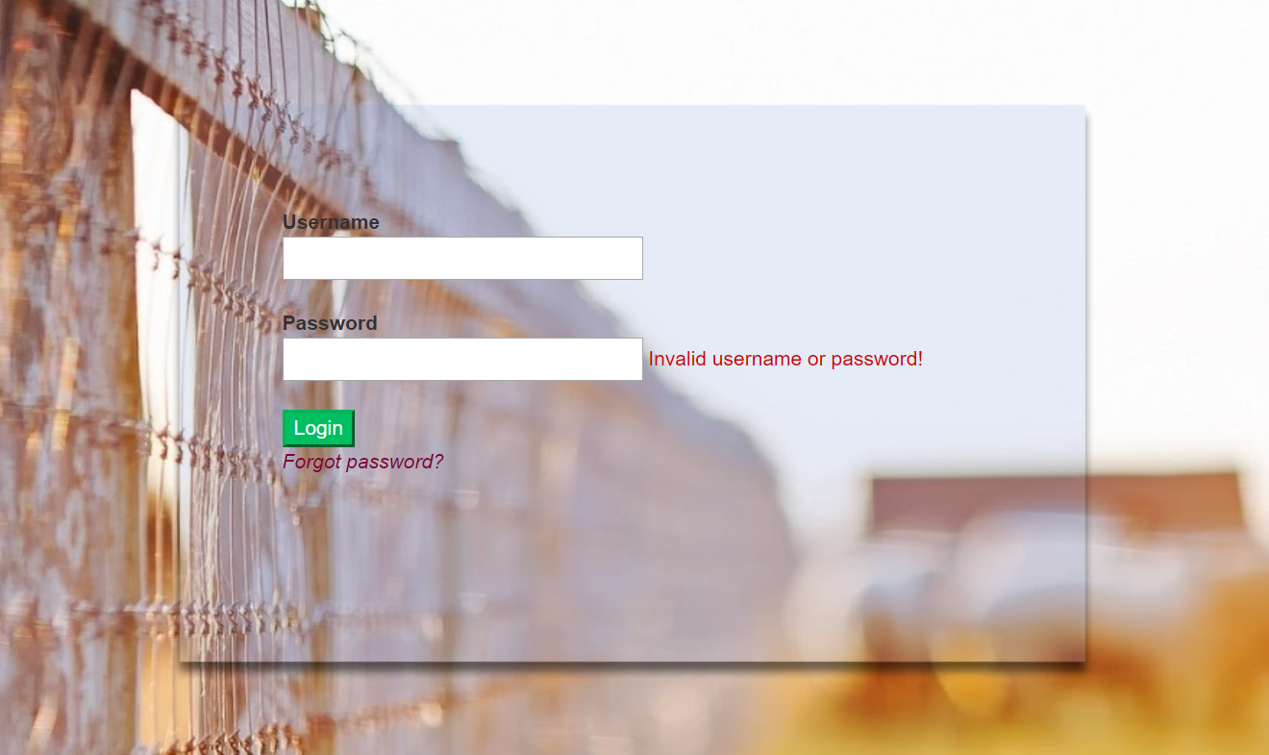**Login:**
* 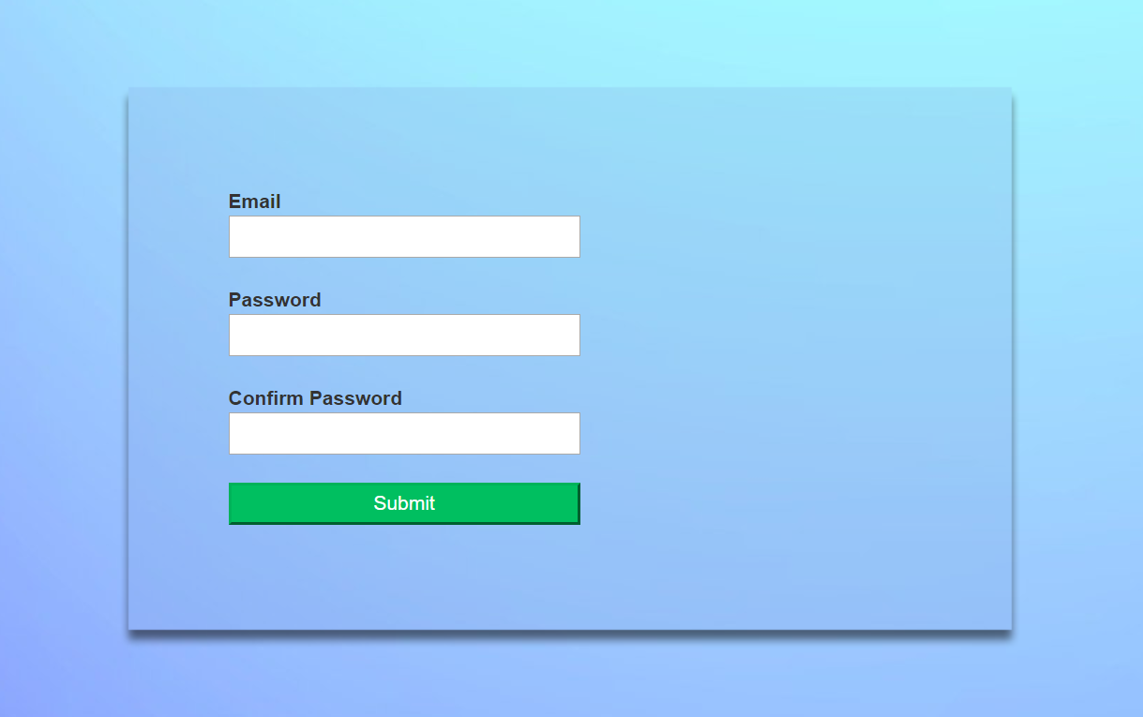**Forgot password:**
* 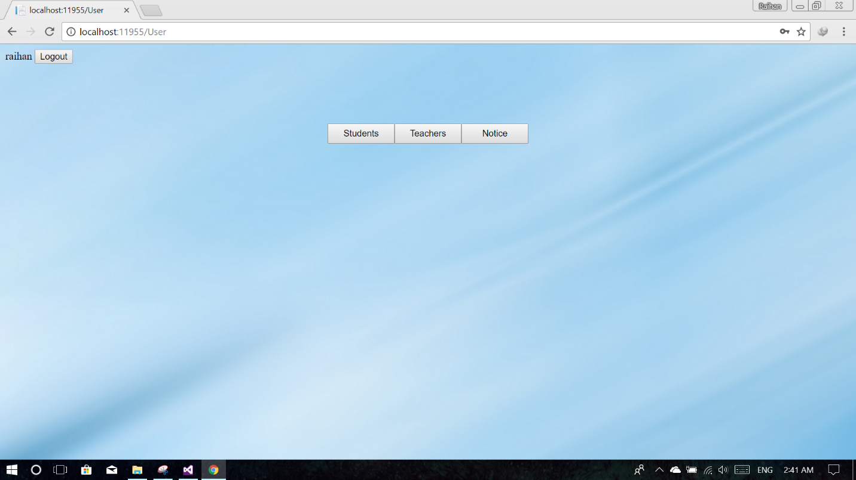**Admin page:**
* 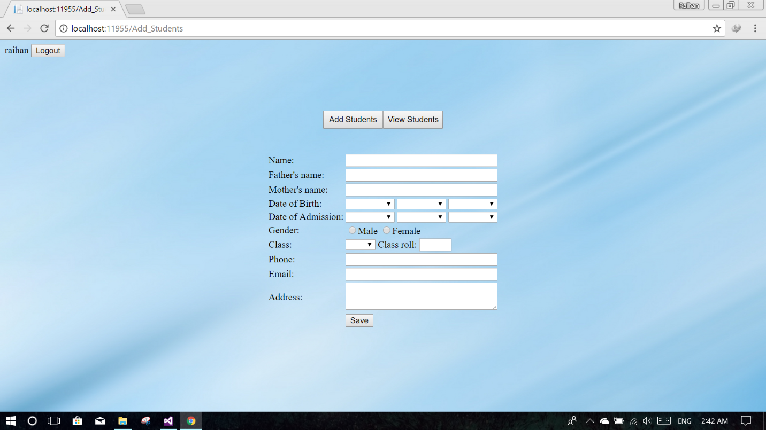**Add students:**
* 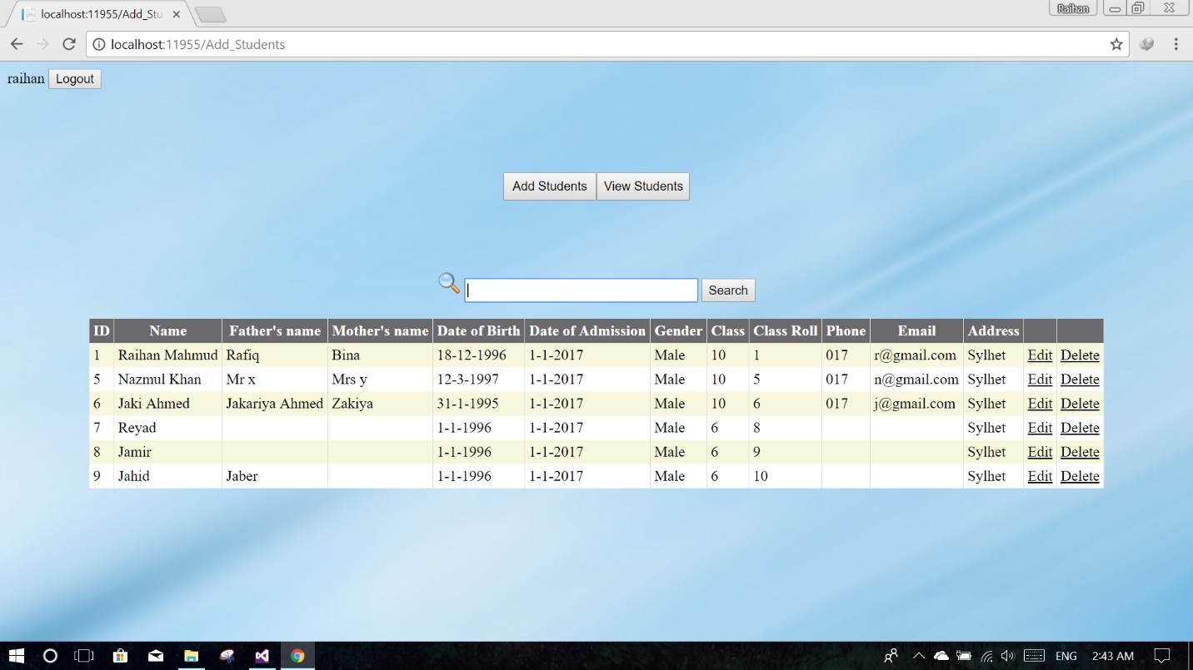**Search students for update/delete:**
* 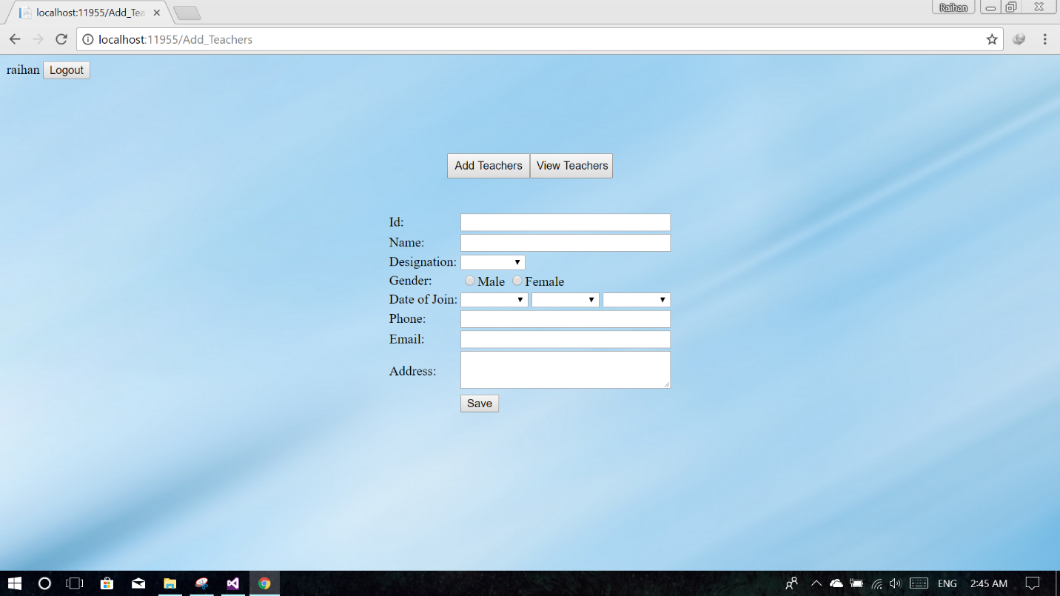**Add teachers:**
* 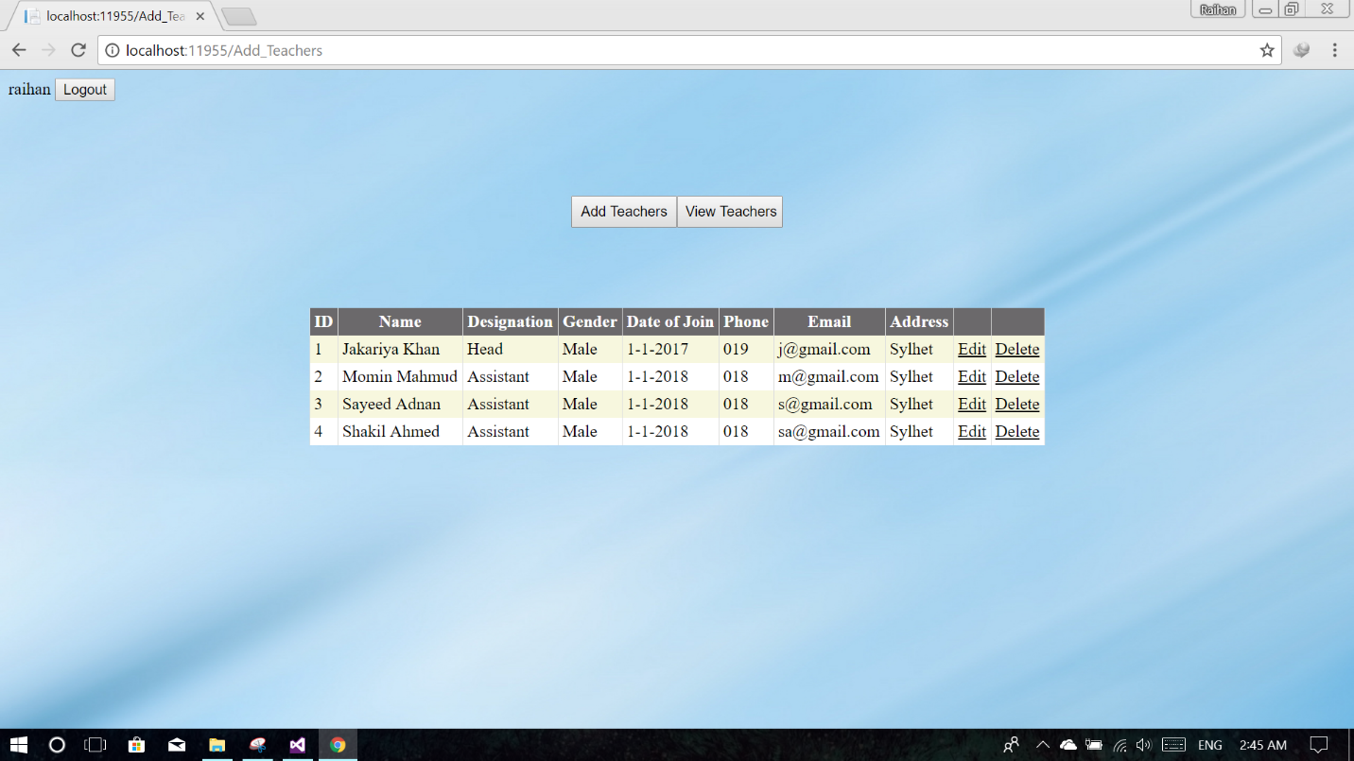**View teachers update/delete:**
* 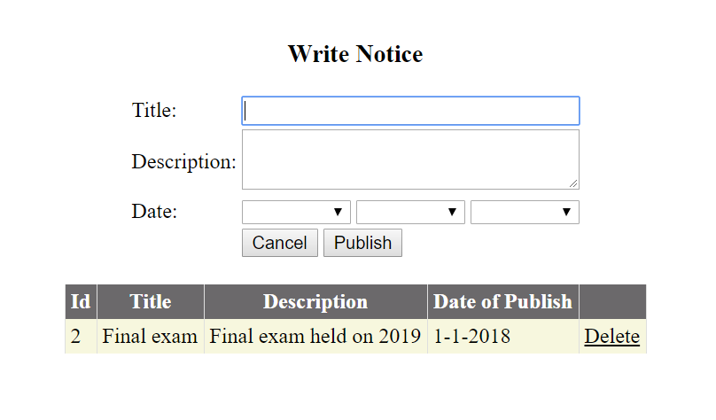**Publish notice/delete:**

**- - -**